John Krohn Lecture

[Generative AI with LLMs: Hands-On Training featuring Hugging Face and PyTorch Lightning](https://youtu.be/Ku9PM26Cc2c?si=czwxg8KAYufPvISp) (100% free)

<https://www.youtube.com/watch?v=Ku9PM26Cc2c>

[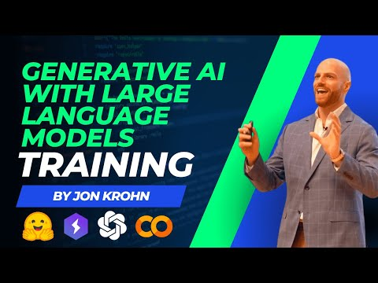](https://www.youtube.com/watch?v=Ku9PM26Cc2c)

[Deep Learning for Natural Language Processing](https://learning.oreilly.com/videos/deep-learning-for/9780136620013/) (free sample [here](https://www.youtube.com/watch?v=rqyw06k91pA))

<https://learning.oreilly.com/course/deep-learning-for/9780136620013/>

He has many other interesting courses

<https://www.jonkrohn.com/courses>

Also the Udemy Courses